wiRE-FRAME

SPAM-HAM

CLASSIFIER

Table of Contents

1.Home page 3

1.1 What is that white box in the homepage? 3

1.2 What is predict button? 3

1.3 What is Results Section? 3

# 1.Home page

We have created home page section in such a way that user will feel very easy to interact with our product. Here is how our home page is Link:

http://ec2-3-140-241-66.us-east-2.compute.amazonaws.com:5000/

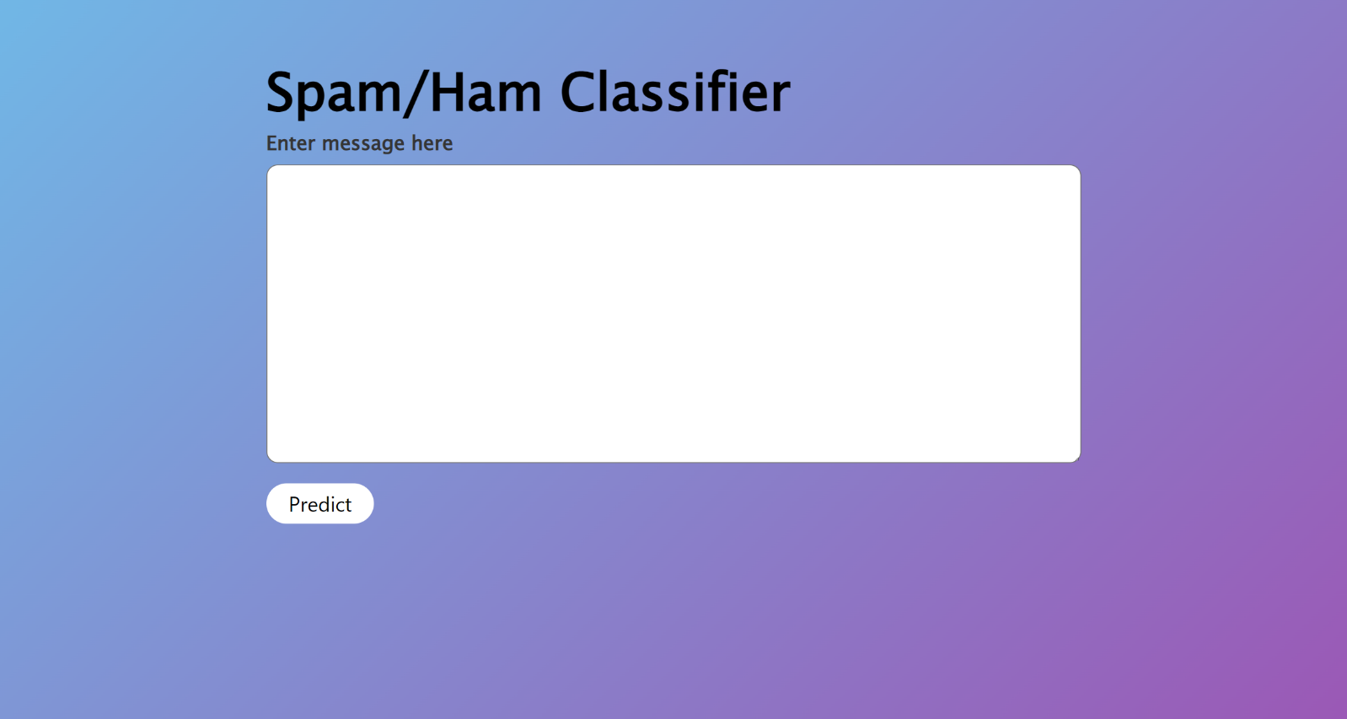

## 1.1 What is that white box in the homepage?

Ans) This is the box where you have to type the message.

## 1.2 What is predict button?

Ans) Upon clicking on this button. The message will be submitted to the backend of the system and data Pre-processing will be done on the message.

## 1.3 What is Results Section?

Ans) The message type will be shown bottom of the page. If the message type is spam then Yes it is a spam message will be shown or else No it is not a spam message

